# **Artificial**

# **Intelligence Essay**

* **Artificial Intelligence**

Artificial Intelligence  refers to the intelligence of machines. This is in contrast to the natural intelligence of humans and animals. With Artificial Intelligence, machines perform functions such as learning, planning, reasoning and problem-solving. Most noteworthy, Artificial Intelligence is the simulation of human intelligence by machines. It is probably the fastest-growing development in the World of [technology and innovation](https://www.toppr.com/bytes/modern-technology/). Furthermore, many experts believe AI could solve major challenges and crisis situations.

1. **Image of AI ROBOT**

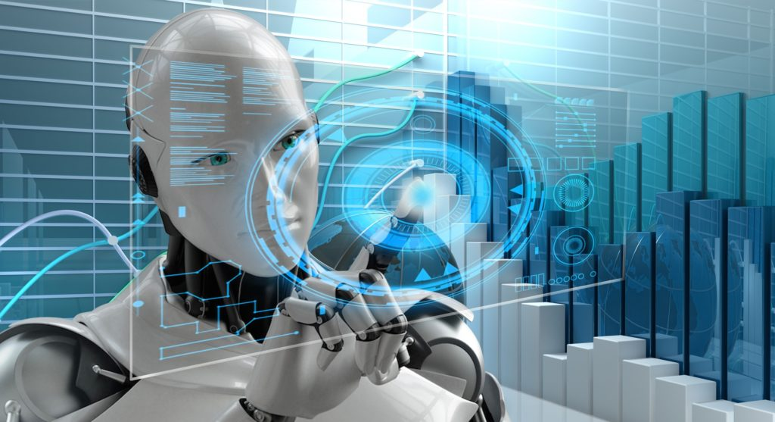

* **Types of Artificial Intelligence**

First of all, the categorization of Artificial Intelligence is into four types. Arend Hintze came up with this categorization. The categories are as follows:

* **Type 1: Reactive machines**

These machines can react to situations. A famous example can be Deep Blue, the IBM chess program. Most noteworthy, the chess program won against [Garry Kasparov](https://www.toppr.com/bytes/artificial-intelligence-what-and-how/), the popular chess legend. Furthermore, such machines lack memory. These machines certainly cannot use past experiences to inform future ones. It analyses all possible alternatives and chooses the best one.

* **Type 2: Limited memory**

**These AI systems are capable of using past experiences to inform future ones. A good example can be self-driving cars. Such cars have**[**decision making systems**](https://www.toppr.com/guides/fundamentals-of-economics-and-management/decision-making/guidelines-for-effective-decision-making/)**. The car makes actions like changing lanes. Most noteworthy, these actions come from observations. There is no permanent storage of these observations.**

* **Type 3: Theory of mind**

**This refers to understand others. Above all, this means to understand that others have their beliefs, intentions, desires, and opinions. However, this type of AI does not exist yet.**

* **Type 4: Self-awareness**

**This is the highest and most sophisticated level of Artificial Intelligence. Such systems have a sense of self. Furthermore, they have awareness, consciousness, and emotions. Obviously, such type of technology does not yet exist. This technology would certainly be a**[**revolution**](https://www.toppr.com/guides/history/french-revolution/about-the-french-revolution/)**.**

* **Applications of Artificial Intelligence**

First of all, AI has significant use in healthcare. Companies are trying to develop technologies for quick diagnosis. Artificial Intelligence would efficiently operate on patients without human supervision. Such technological surgeries are already taking place. Another excellent healthcare technology is IBM Watson.

Artificial Intelligence in business would significantly save time and effort. There is an application of robotic automation to human business tasks. Furthermore, [Machine learning](https://www.toppr.com/bytes/machine-learning/) algorithms help in better serving customers. Chatbots provide immediate response and service to customers.

AI can certainly make education more efficient. AI technology can discover the needs of students. Then it can adapt according to their needs. AI tutors provide study help to students. Also, AI can automate grading which results in saving a lot of time.

AI can greatly increase the rate of work in manufacturing. Manufacture of a huge number of products can take place with AI. Furthermore, the entire production process can take place without human intervention. Hence, a lot of time and effort is saved.

Artificial Intelligence has applications in various other fields. These fields can be [military](https://www.toppr.com/guides/general-awareness/economics-and-governance/defense/), [law](https://www.toppr.com/guides/civics/understanding-laws/understanding-laws-of-india/), [video games](https://www.toppr.com/bytes/are-there-benefits-to-playing-video-games/), government, finance, automotive, audit, art, etc. Hence, it’s clear that AI has a massive amount of different applications.

To sum it up, Artificial Intelligence looks all set to be the future of the World. Experts believe AI would certainly become a part and parcel of human life soon. AI would completely change the way we view our World. With Artificial Intelligence, the future seems intriguing and exciting.